**Lesson 23 Cíntia Domingos**

**Beet Seed**

**1.**

SELECT *

FROM Shopping_List

WHERE Product_name LIKE 'a%';

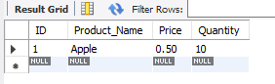

**4.**

SELECT Shopping_List.Product_name

FROM Shopping_List

INNER JOIN Fridge

ON Shopping_List.ID = Fridge.Product_ID;

**Beet Sprout**

**2.**

SELECT Shopping_list.Product_name, Shopping_list.ID

FROM Shopping_list

WHERE Shopping_list.ID NOT IN (SELECT Shopping_List.ID

FROM Shopping_list

JOIN Fridge

ON Shopping_list.ID = Fridge.Product_ID);

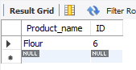

**Mighty Beet**

**2.**

CREATE TABLE Orders(

Order_ID INT PRIMARY KEY AUTO_INCREMENT,

Product_ID INT,

Item_ID INT,

Date DATE,

Quantity INT

);

**3.**

INSERT INTO Orders(Product_ID, Item_ID, Date, Quantity)

VALUES (NULL, NULL, 2024-03-02, 10),

(NULL, NULL, 2024-05-03, 15);

**4.**

ALTER TABLE Orders

ADD FOREIGN KEY (Product_ID) REFERENCES Shopping_list.ID

ADD FOREIGN KEY (Item_ID) REFERENCES Fridge.Item_ID;

**5.**

INSERT INTO Orders (Product_ID, Item_ID, Date, Quantity)

SELECT Shopping_list.ID, Fridge.Item_ID, CURRENT_DATE(), Shopping_list.Quantity

FROM Shopping_list

LEFT OUTER JOIN Fridge ON Shopping_list.ID = Fridge.Product_ID

UNION

SELECT Shopping_list.ID, Fridge.Item_ID, CURRENT_DATE(), Shopping_list.Quantity

FROM Fridge

LEFT OUTER JOIN Shopping_List ON Shopping_list.ID = Fridge.Product_ID;

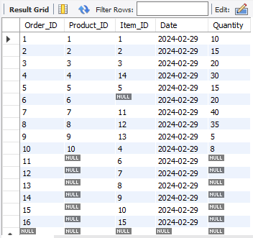

**6.**

SELECT Order_ID, Orders.Product_ID, Product_name, Date, Expiration_Date

FROM Orders

INNER JOIN Fridge

ON Fridge.Product_ID = Orders.Product_ID

WHERE Orders.Product_ID <> 'NULL' /* this selects only what's in the shopping list, i.e., has a Product_ID (ID in the shopping_list table) */

AND Expiration_date < Orders.Date;

